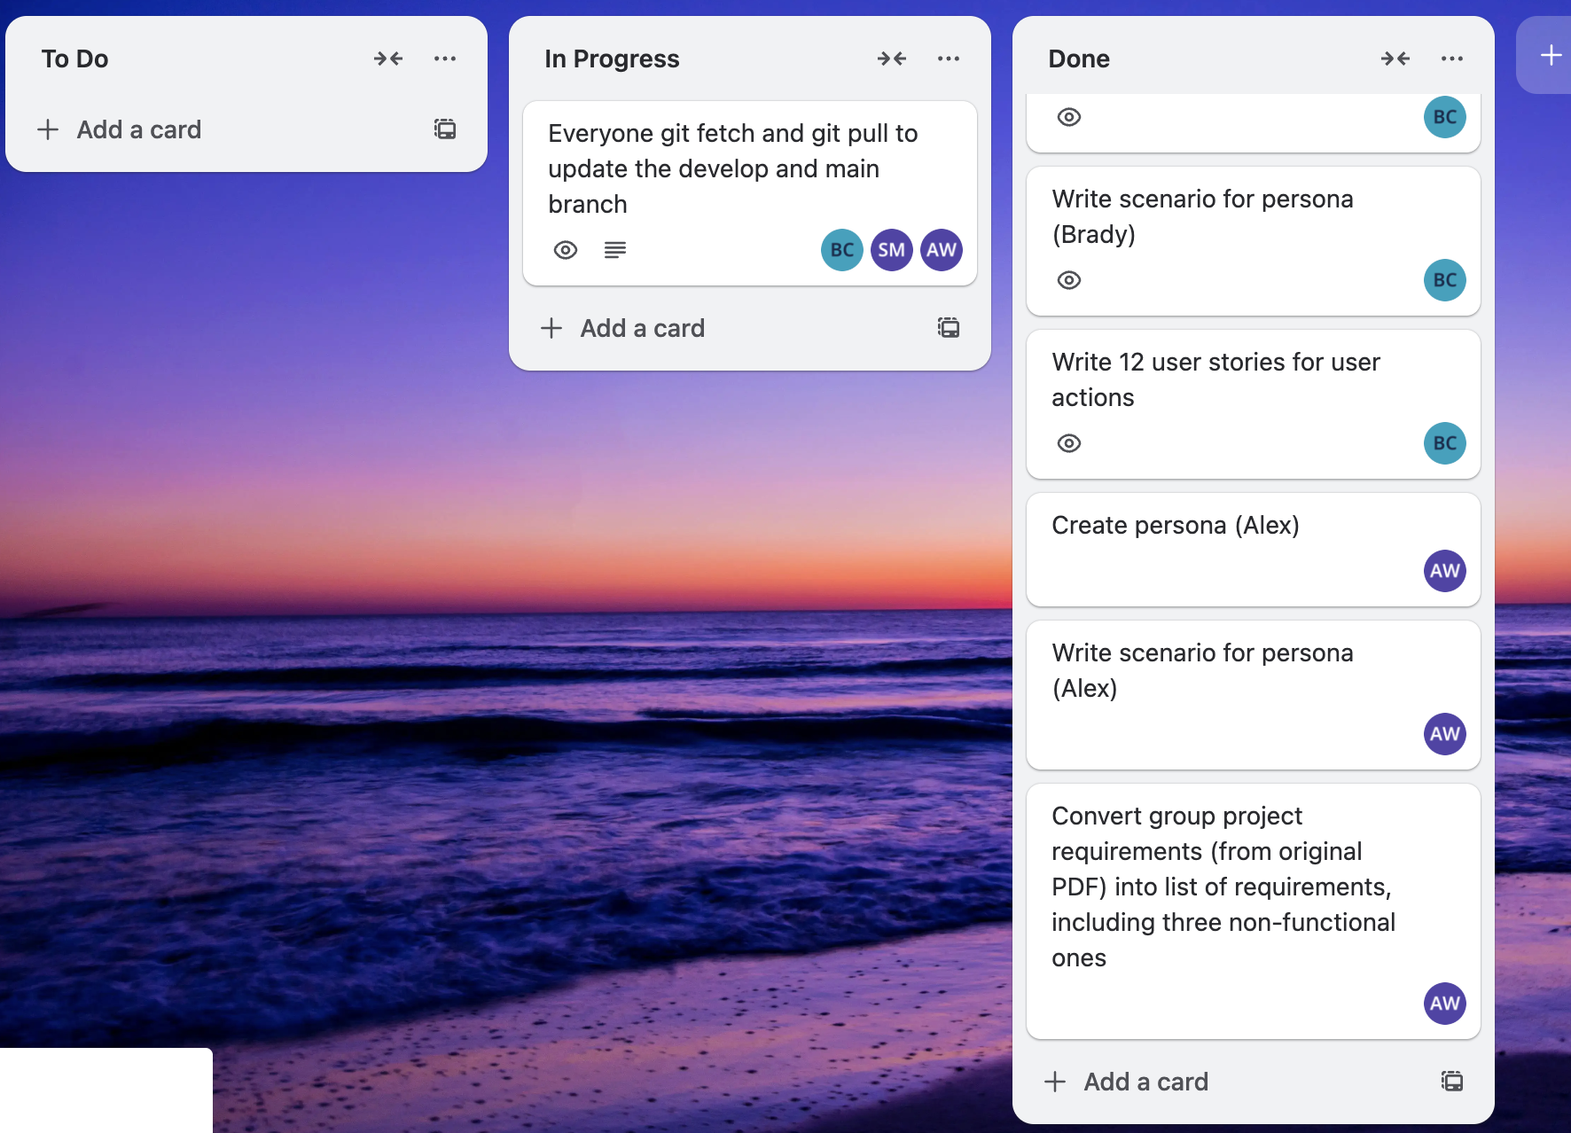Personas
Brady persona

Alan Yu was born on November 10, 2000 to parents Renlong Yu and Yilin Chen in Flushing, Queens. He attended Flushing High School, where he was on the track team and also played violin. After this, he took classes at Queens College as a commuter student, graduating with a degree in accounting. For about a year, Alan worked remotely at a Philadelphia-based company; however, they have just offered him the chance to work in-person. Alan loves his parents, but he wished to finally live independently from them, so he accepted the transfer. Now Alan and his friend Derek Wong live in a rented apartment in the Center City neighborhood. Their apartment is pretty bare, and Alan needs furniture. His family has always been frugal, and that trait has been passed down to Alan. He wants to buy good, comfortable furniture, but not at a price that would break the bank. Also, he might be in the market for a new violin.

Goals: Buy furniture at a low cost, buy a violin

Scenario:
Alan logs into app
Alan searches for sofas and sees one he likes
Alan enters his budget ($1500)
Alan submits his request to purchase the sofa

Alex persona
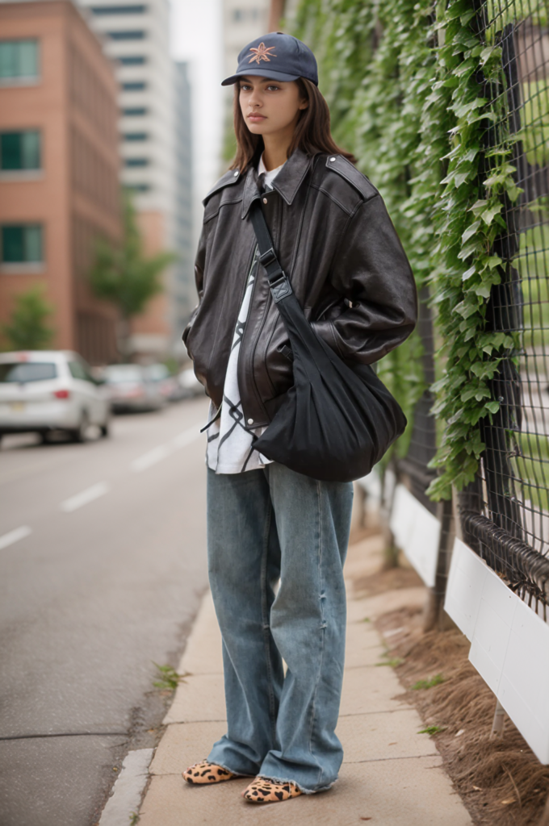
Emily Santos is 24 and lives in Brooklyn with two friends. She works at a small marketing agency in Manhattan. Emily has always been interested in fashion and streetwear. She spends a lot of time thrifting, shopping for unique pieces, and mixing streetwear with vintage items. She also enjoys playing niche video games and going out with friends.
Emily’s apartment is filled with posters, sneakers, and clothes racks, but she is always on the lookout for new pieces to add to her wardrobe. She scrolls through resale apps often, sometimes just to see what trends are popping up. She tries not to overspend and likes finding good deals on clothes and accessories.

Scenario:
Emily opens app.
Logs in.
Browses her followed users to see if anything she likes is up for sale.
Finds a pair of adidas shoes she likes, but is too expensive.
Submits an offer at a lower price.

Sam persona


George is an up and coming artist in midcoast Maine. He’s working on a new project that will use recycled vintage items to create a sculpture representing Maine’s history. He lives in a small house with few amenities other than the bare essentials and the resources he needs for his artwork.

He often hunts for unique second-hand objects at flea markets, yard sales, and online resale apps. He’s especially interested in weathered wood, old buoys, ropes, rusted metal hardware, and anything that tells a story of Maine’s coastal communities. George works on a shoestring budget, preferring to invest most of his money into quality materials for his art while keeping his living expenses as low as possible.

Scenario:
Opens the app
Logs in
Browses for vintage items within a specific region
Submits 2 lowball requests
Closes the app

Requirement list

Functional Requirements
- Sellers post items with pictures, descriptions, and pricing info.
- Interested buyers must fill out a request form explaining their reason for interest or budget.
- Sellers (or marketplace admins) must approve the buyer request before any item is finalized.
- If multiple users want the same item, the seller selects the buyer.
- The system should track approved requests and allow basic messaging or confirmation.
- The web application must be protected by a login screen.
- A user registration screen is optional.
- All user input must be validated before being processed to prevent potential system abuse or security threats.

Technical Requirements
- Must be a 3-tier web app.
- Frontend: React (Vite).
- Backend: Python Flask.
- Database: SQLite.
- Must run in Docker containers (at least frontend + backend).
Non Functional Requirements
- The system must store data persistently so items, users, and requests are not lost when the server restarts.
- The system should load item listings within 2 seconds under normal use.
- The system must validate all user input to prevent errors or security issues.

Feature list
- Login System
- User Profile
  - Interests
  - listings
  - Previously bought
- Listings
  - Create listing with photo, price, and description
  - Ability to bid
  - Geography
  - Category
- Messaging
  - Allow users to message listers
- Follow / Unfollow
- Search feature
  - Key word search
  - Filter by price
  - By location
  - By following
  - By category
- Payment system
  - credit / debit
  - address
- Bid system
  - Ability to place bid
  - Automatically increases the next qualifying bid
  - Sets deadline for sale
- Confirmation
  - Confirms when objects are shipped

User stories
- As a buyer, I want to find products at a low price so I can find the things I need without breaking the bank.
- As a seller, I want to be able to sell my products so I can make money and get rid of unneeded items.
- As a buyer, I want to be able to sort products by price so I can find the cheapest ones.
- As a buyer, I want to be able to search for products by name so I can find what I’m looking for.
- As a teacher, I need to buy supplies for my students so they can have the things they need to succeed in school.
- As a film student, I need to buy props so I can make a good movie.
- As a seller, I want to be able to set my own price for my listings so I can get the amount of money I feel I’m owed.
- As a user, I want to be able to create an account to buy and sell products.
- As a user, I want to be able to reset my password in case I forget.
- As a seller, I want to be able to set the name for my product so buyers will know exactly what they’re getting.
- As a buyer, I want to be able to view all products of a certain category so I can compare different but similar products.
- As a seller, I want to set what category my product is in so users know what kind of product it is.

